MRMv2 RequisitePro Extension

MRMv2 RequisitePro Extension 1
What is it? 1
Installation and Setup 1
Pre-Requisites 1
Launch Program 2
User Interface 2
Apache Software License 5

What is it?

The MRMv2 RequisitePro extension is a java application that allows MRMv2 business analysts the ability to import and export business component matrices. It also produces a text file outlining the metadata structure being used by RequisitePro. This application includes software developed by the Apache Software Foundation (http://www.apache.org/)."

Installation and Setup

MRMv2_Reqpro.jar is an executable jar file that requires no installation but does require some setup of the user PC.

Pre-Requisites
- Install latest Java Runtime Environment (JRE) on PC before running MRMv2_ReqPro.jar
- RequisitePro should be installed on pc that is trying to execute MRMv2_ReqPro.jar. If the machine does not have or want to install RequisitePro, two dll files need to be registered (use windows regsvr32 command) on the PC for the jar to run.
  - RJCB.dll
  - ReqProBridge.dll
- MRMReqPro.properties file must be copied to the RequisitePro server project that this program works with. If the properties file is not present the application will not run.(ie. if working with RequisitePro Projectx then copy properties file to: <RequisitePro install location>/Projects/Projectx) This properties file contains two properties, log and deprecateAttrName. If the log=on, then a log file is created during each run of this application in the RequisitePro project directory used at login. The deprecateAttrName property should contain the name of the attribute in the RequisitePro project that reflects if instances are deprecated or not. The properties are defaulted to log=off and deprecateAttrName=Deprecated.

Launch Program
- No install required, simply execute (double click file) MRMv2_ReqPro.jar to launch program
- Optional - A project parameter can be supplied to the program if you want to auto select the RequisitePro project during launch. The run.bat file shows an example of this. Simple execute the bat file and the program will launch with the RequisitePro project auto populated. As shown in the run.bat file, the windows command to run the application with a parameter is as follows:
start javaw -jar MRMv2_ReqPro.jar "C:\Documents and Settings\Administrator\Desktop\ReqPro\Gotham City\Gotham City.rqs"
This example shows the launch of the program using a RequisitePro project called Gotham City located on the user desktop.

User Interface

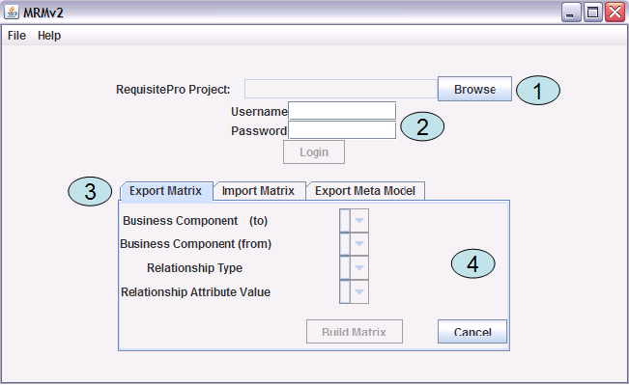

- The Browse button allows users to select the RequisitePro project they wish to work with.
- Once the RequisitePro project is selected, the user is required to provide their RequisitePro username and password.
- After logging into the project, the following three tabs are populated with content - Export Matrix, Import Matrix and Export Meta Model.
- Export Matrix – This tab allows a user to build a matrix by selecting the two business components ((to) will be on x axis and (from) will be on y axis of matrix) they wish to have participate. If the MRM meta model allows for a relationship to exist between the business components selected, the Relationship Type drop down will be populated along with the Relationship Attribute Value. It is the Relationship Attribute Value that will be populated in the cells of the matrix. For example, if a user wanted to export a matrix showing the effective to date of relationships between their Programs and Services they would do so as follows:

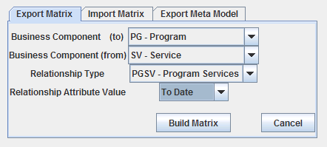

Once the appropriate items are selected the Build Matrix button is pressed to create the matrix. This will prompt the user for a location on their hard disk of where the matrix (excel spreadsheet) should be saved. Once complete, the application will close and the user may open the newly created matrix. Figure 1 shows an example of the Matrix (in this example no relationships exist).

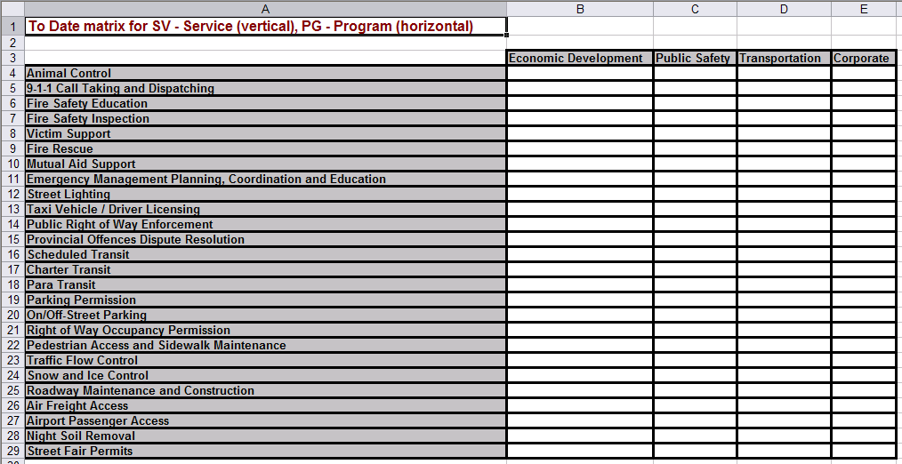
Figure 1. Matrix

Import Matrix - This tab allows a user to import a matrix. It is recommended that users import matrices that where previously exported by this tool as to ensure that formatting is correct. The user should also ensure that when importing that the correct business components, relationship, and relationship value are selected to match what is contained in the matrix. Once all the correct information is selected the Browse button is used to select the matrix file to import.

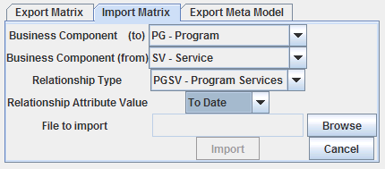

Once the file is selected the Import button is used to import the matrix into RequisitePro. After completing the import the program will close.

Export Meta Model – This tab is used to export to a text file the meta model structure being used by the RequisitePro project (Note. This structure may also be viewed in RequisitePro, see requirement types and attributes).

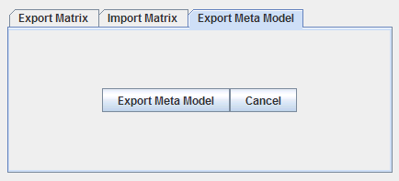

Selecting the Exporting Meta Model button will prompt the user to select a file location on their computer. Once selected, a text file is created with the meta model information and the program will close. Figure 2 shows an example of this export.

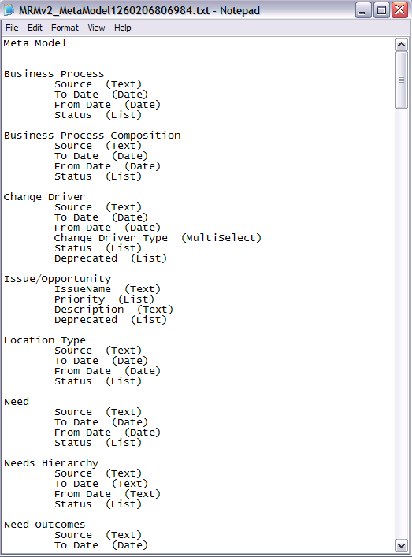
Figure 2. Meta Model Export

Apache Software License

** This application uses source code from Apache to manipulate excel spreadsheets: poi-3.2-FINAL-20081019.jar

The Apache Software License, Version 1.1

Copyright (c) 2000 The Apache Software Foundation. All rights
reserved.

Redistribution and use in source and binary forms, with or without
modification, are permitted provided that the following conditions
are met:

1. Redistributions of source code must retain the above copyright
notice, this list of conditions and the following disclaimer.

2. Redistributions in binary form must reproduce the above copyright
notice, this list of conditions and the following disclaimer in
the documentation and/or other materials provided with the
distribution.

3. The end-user documentation included with the redistribution,
if any, must include the following acknowledgment:
"This product includes software developed by the
Apache Software Foundation (http://www.apache.org/)."
Alternately, this acknowledgment may appear in the software itself,
if and wherever such third-party acknowledgments normally appear.

4. The names "Apache" and "Apache Software Foundation" must
not be used to endorse or promote products derived from this
software without prior written permission. For written
permission, please contact apache@apache.org.

5. Products derived from this software may not be called "Apache",
nor may "Apache" appear in their name, without prior written
permission of the Apache Software Foundation.

THIS SOFTWARE IS PROVIDED ``AS IS'' AND ANY EXPRESSED OR IMPLIED
WARRANTIES, INCLUDING, BUT NOT LIMITED TO, THE IMPLIED WARRANTIES
OF MERCHANTABILITY AND FITNESS FOR A PARTICULAR PURPOSE ARE
DISCLAIMED. IN NO EVENT SHALL THE APACHE SOFTWARE FOUNDATION OR
ITS CONTRIBUTORS BE LIABLE FOR ANY DIRECT, INDIRECT, INCIDENTAL,
SPECIAL, EXEMPLARY, OR CONSEQUENTIAL DAMAGES (INCLUDING, BUT NOT
LIMITED TO, PROCUREMENT OF SUBSTITUTE GOODS OR SERVICES; LOSS OF
USE, DATA, OR PROFITS; OR BUSINESS INTERRUPTION) HOWEVER CAUSED AND
ON ANY THEORY OF LIABILITY, WHETHER IN CONTRACT, STRICT LIABILITY,
OR TORT (INCLUDING NEGLIGENCE OR OTHERWISE) ARISING IN ANY WAY OUT
OF THE USE OF THIS SOFTWARE, EVEN IF ADVISED OF THE POSSIBILITY OF
SUCH DAMAGE.
====================================================================

This software consists of voluntary contributions made by many
individuals on behalf of the Apache Software Foundation. For more
information on the Apache Software Foundation, please see
<http://www.apache.org/>.

Portions of this software are based upon public domain software
originally written at the National Center for Supercomputing Applications, University of Illinois, Urbana-Champaign.

